# Kickstarter analysis of outcomes of 4000 past projects

## Given the provided data, what are three conclusions we can draw about Kickstarter campaigns?

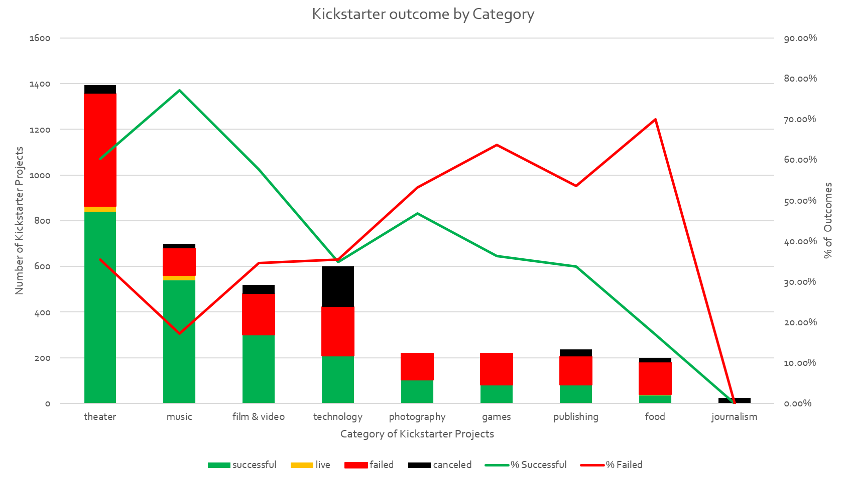

1. There are more successful “theater” projects than any other category (839 Total)
2. “music” projects have the highest % Success / % Failed ratio of any category (77.14%/17.49% = 4.5)
3. There are “Sub-Categories” that have project types with 100% Success rates with fairly large sample sizes (n >= 60):
   1. Rock (260) > Documentary (180) > Hardware (140) > Tabletop games (80) > Television (60), Shorts (60), NonFiction (60)

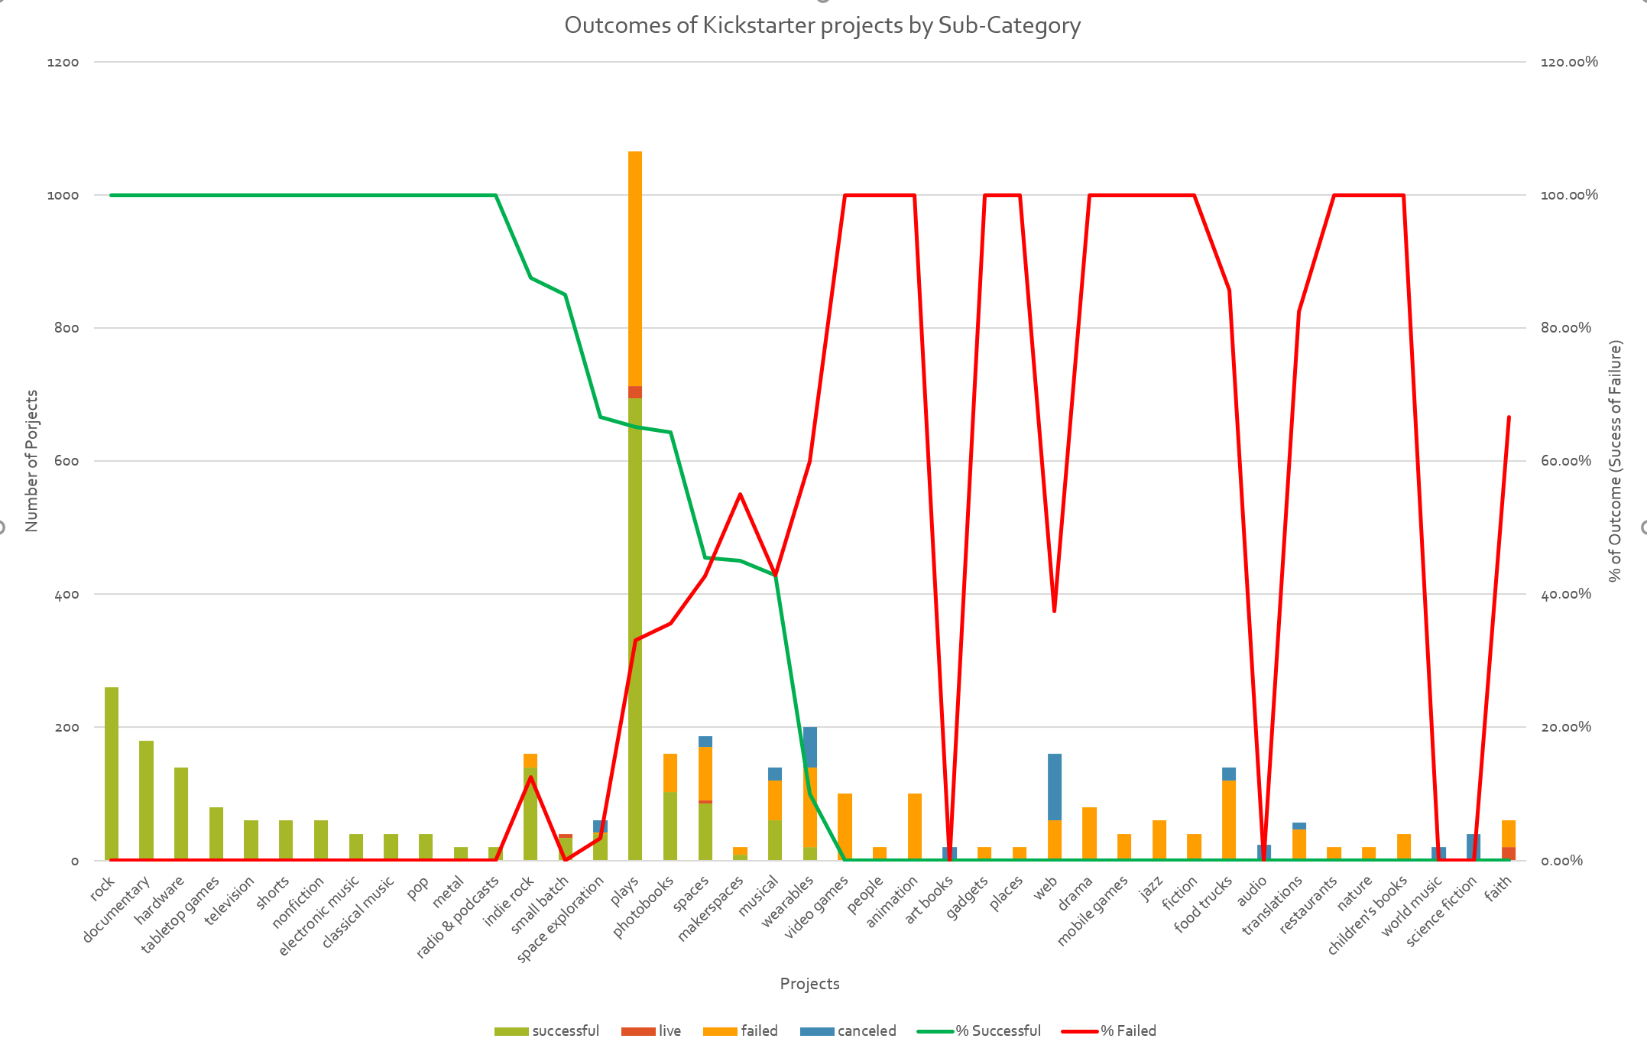

## What are some limitations of this dataset?

The dataset is not the entire set of Kickstarter projects – it is just a small sample of 4000 – as stated in the opening there are more than 300,000 projects launched on Kickstarter.

How was the data sampled? Was it done is a non-bias way? That information is not given, so there is some question as to the validity of any conclusions that can be drawn from the data.

A quick review of the Kickstarter website shows the data has changed since the creation of this assignment:

468,826 launched projects

174,094 successfully funded projects

290,986 Unsuccessfully funded projects

A further look into the data shows that the current website has additional categories not represented in the dataset we are provided.

Namely, “Dance, Comics, Art, Design, Fashion and Crafts” are not included in our sample set.

Plotting out the success rates that the current Kickstarter website has (<https://www.kickstarter.com/help/stats>) shows that these omitted categories have would impact our conclusion that “Theater” is the category with the highest success rate:

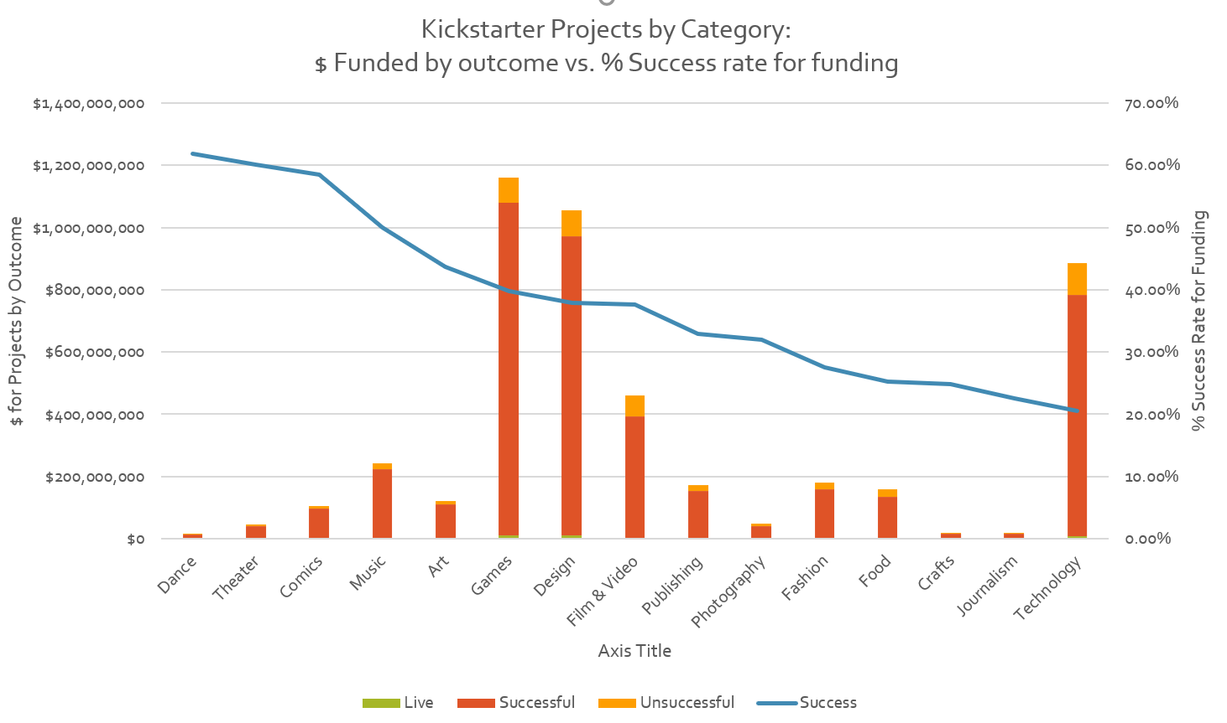

## What are some other possible tables and/or graphs that we could create?

Finding what correlates with a high project funding rate would help us have recommended actions that could be taken to increase the chance of finding Kickstarter projects that we could pursue with the highest likelihood of the project being ultimately funded.

One parameter of interest could be the correlation (if any) between whether a project is a staff pick and if it is funded.

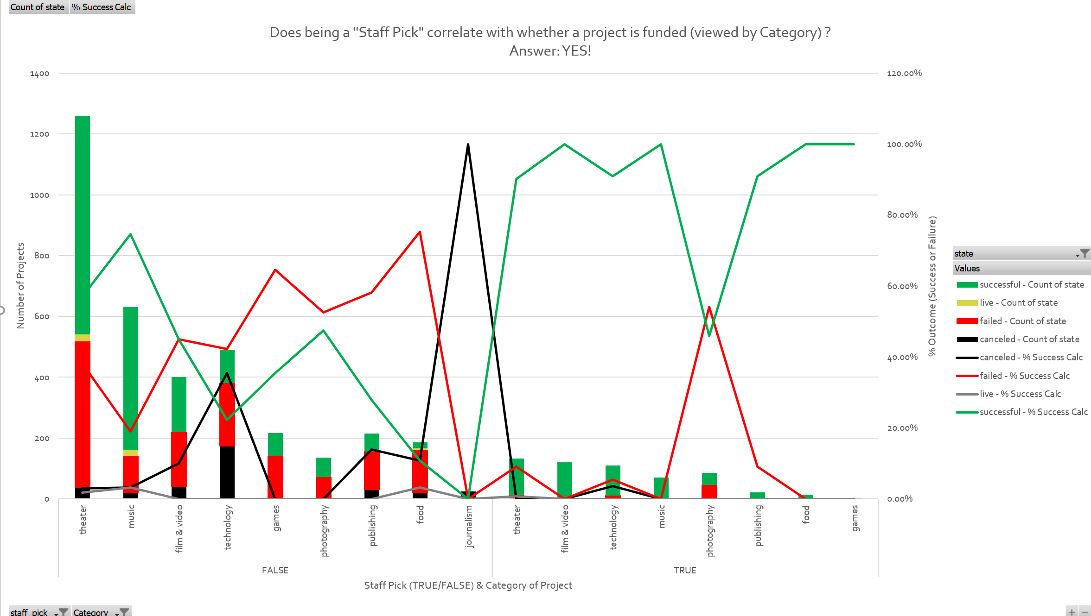

The answer seems to be that “Yes” – if a project is a Staff Pick it has a very high success rate as compared to if it is not compared by Category.